An Independent Inquiry Into the American Origins of Covid?
  - RON UNZ • JUNE 12, 2022 • 1,400 WORDS • 154 COMMENTS • REPLY

From: https://www.unz.com/runz/an-independent-inquiry-into-the-american-origins-of-covid/

As most are surely aware, for more than two years I have been pointing to the strong perhaps even overwhelming evidence that the Covid outbreak that devastated our own country and the world was very likely the result of an exceptionally reckless American biowarfare attack against China (and Iran).
Under my analysis, the million American deaths and massive social disruption we have suffered would constitute the most disastrous blowback of any military operation in the history of the world, and if it became widely accepted, the domestic political consequences would be monumental.
My suggestion of a central American role in the creation of this global epidemic has been excluded not only from the mainstream media but from virtually all of the alternative media as well, presumably because the possibility is simply too horrific to contemplate. However, this situation may now be starting to change.
Last month, the prestigious journal Proceedings of the National Academy of Sciences carried an opinion article authored by prominent Columbia University economist Jeffrey D. Sachs and a medical colleague suggesting an American role in the creation of the virus and arguing for an independent inquiry into that possibility.
Their paper also presented some of the very considerable evidence that the virus had been artificially engineered in a laboratory, providing a comparison chart noting the striking difference in structure between Covid and all of its closest natural relatives. Indeed, the former seems to have the sort of human-insert sequence that American researchers had been exploring in their scientific papers.
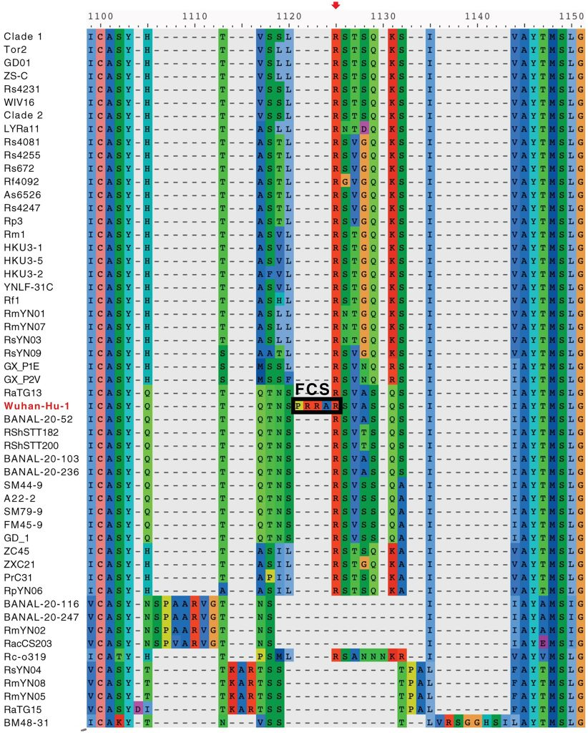
[In the above, FCS is the enigmatic Furin-Cleavage Site. SARS-COVID-19 was first seen in Iran and Wuhan China with this variant. For more on the FCS, see 20211203 the Quasispecies Origins of SARS-CoV-2’s Enigmatic Furin-Cleavage Site+++++.htm . At 20210401 Part II, Quasispecies Mutant Swarm+++++.htm is even more. ]
Sachs and his co-author also emphasized that the Eco-Health Alliance, heavily funded by our own Department of Defense, had been very active in organizing the collection of SARS-like bat-viruses from China, exactly the sort of viruses that probably would have constituted the precursor stock to a genetically-engineered Covid virus.
These sorts of implications are hardly surprising to those who have been following my own writings of the last couple of years, but they obviously have vastly greater impact when made by top mainstream scholars writing in one of America’s most influential academic journals. Although the two authors are careful to avoid touching upon the central thesis of my own articles, their analysis is entirely consistent with that framework.
- A call for an independent inquiry into the origin of the SARS-CoV-2 virus
Neil L. Harrison and Jeffrey D. Sachs • PNAS • May 19, 2022 • 2,800 Words
So far, this potentially important paper seems to have received relatively little media coverage, but it may have already contributed to some renewed interest in my own work.
In February I had presented my ideas at length in several video interviews, including Kevin Barrett’s Truth Jihad, Geopolitics & Empire, and Red Ice TV, totaling nearly four hours of discussion. During the last ten days or so, these videos have attracted a great deal of new interest, adding another 60,000 total views, and are now rapidly approaching the half-million mark. Shortly after my interview with Kevin Barrett, he told me he hoped that the viewership might eventually break 100,000, a possibility I considered wildly optimistic at the time, but that video is now actually at the verge of reaching 200,000 views. If these trends continue, at some point media outlets may finally be forced to recognize the likely reality of what befell America and the rest of the world a couple of years ago.
- Video Link ABC Early Virus Warning (15 minutes) +++++ [You must listen up through the 11th minute!]
- Video Link Ron Unz: COVID-19 WAS AN ANTI-ECONOMY BIOWEAPON BY THE U.S> AGAINST CHINA (1 hour 16 minutes) +++++
- Video Link Ron Unz INTERVIEWS on BIOWARFARE (2 hour 15 minutes) +++

Meanwhile, I have recently been preoccupied with different matters. In June 2018 I resumed my writing, ….

